**Psalm 32**

Unaccompanied

*Beati, quorum*

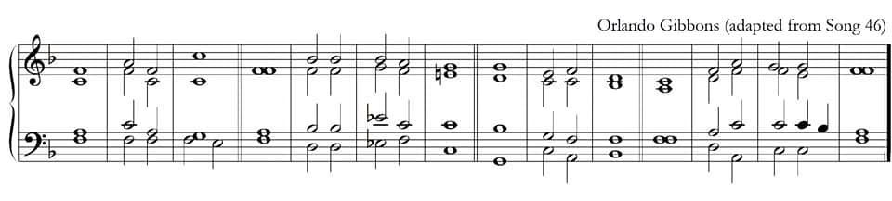

***mf*** 1. Blessèd is he whose unrighteousness | is for-|giv’n :

() | and whose |sin is |**cov**er’d.

2.  Blessèd is the man unto whom the Lord im-|puteth **·** no | sin :

and in whose | spirit **·** there | is no | guile.

***p*** 3.  For while I | held my | tongue :

my bones consumed away | through my | daily **·** com-|**plain**ing.

4.  For thy hand is **heavy** upon me | day and | night :

and my moisture is | like the | drought in | **sum**mer.

***mp*** 5.  I will acknowledge my | sin un-to | thee :

and mine un-|righteous-ness | have I not | hid.

6.  I said I will confess my sins | unto **·** the | Lord :

and so thou forgavest the | wicked-ness | of my | sin.

***mf*** 7.  For this shall **ev’ry** one that is **god**ly make his **pray’r** unto **thee**,*

in a **time** when thou | mayest be | found :

but in the great water-floods | they shall | not come | **nigh** him.

8.  Thou art a place to hide me in,*

thou shalt pre-|serve me **·** from | **trou**ble :

thou shalt **com**pass me a-|bout with | songs of **·** de-|**liv**’rance.



9.  I will in**form** thee and **teach** thee in the **way** wherein | thou shalt | go :

and I will | guide thee | with mine | eye.

10.  Be ye not like to horse and mule which have no | under-|**stan**ding :

whose mouths must be held→

with bit and bridle | lest they | fall up-|**on** thee.

11.  Great plagues remain | for the **·** un-|**god**ly :

but whoso **put**teth his **trust** in the **Lord**,*

mercy em**brace**th | him on | ev’ry | side.

***f*** 12.  Be glad O ye righteous and re-|joice in **·** the | Lord :

and be **joy**ful all | ye that **·** are | true of | heart.

***mf*** Glory be to the Father,* and | to the | Son:

and | to the | Ho-ly | Ghost;

As it was in the beginning, * is now and | ev-er | **shall** be:

World without | end. * A | - | men.