Psalm 67

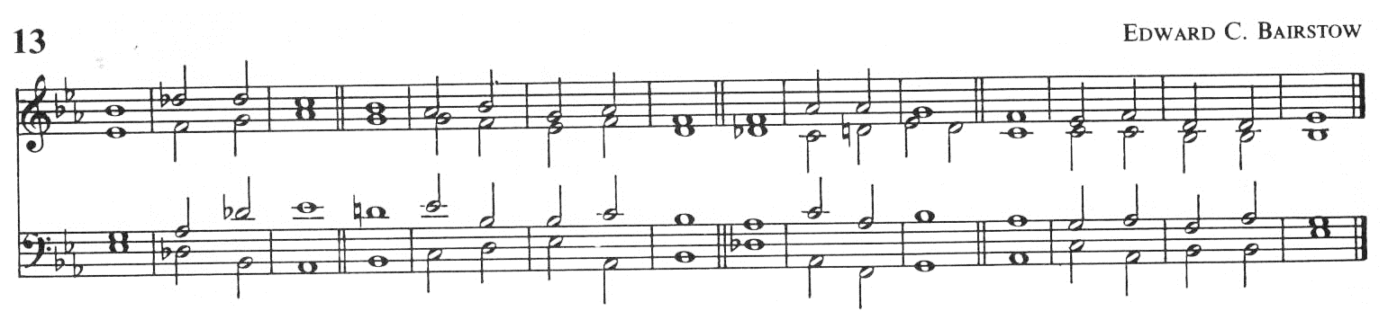

1. God be merciful unto | us and | **bless** us:

and shew us the light of his countenance * | and be | merci-ful | **un**to us:

2. That thy way may be | known up-on | earth:

thy saving | health a-| mong all | **na**tions.

*Unison ff* 3. *Let the people | praise thee* **·** *O | God : yea let | all the | people |* ***praise*** *thee.*

4. O let the nations re-| joice and **·**be | glad:

for thou shalt judge the folk **right**eously,* and | govern **·** the | nations up-on |

earth.

*Unison ff* 5. *Let the people | praise thee* **·** *O | God : let | all the | people |* ***praise*** *thee.*

6. Then shall the earth bring | forth her | **in**crease:

and God, even our own | God shall | give us **·** his | **ble**ssing.

*2nd part* 7. **God** | shall | **bless** us : and all the | ends of **·** the | world shall | **fear** him.

Glory be to the Father* and | to the | Son :

and | to the | Holy | Ghost:

As it was in the beginning,* is now and | ever | **shall** be:

world without | end.* A | - | men.